Question 1:

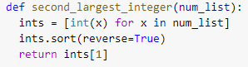

def second_largest_integer(num_list):

ints = [int(x) for x in num_list]

ints.sort(reverse=True)

return ints[1]

Question 2:

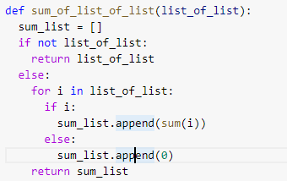

def sum_of_list_of_list(list_of_list):

sum_list = []

if not list_of_list:

return list_of_list

else:

for i in list_of_list:

if i:

sum_list.append(sum(i))

else:

sum_list.append(0)

return sum_list

Question 3:

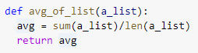

def avg_of_list(a_list):

avg = sum(a_list)/len(a_list)

return avg

Question 4:

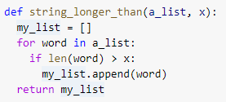

def string_longer_than(a_list, x):

my_list = []

for word in a_list:

if len(word) > x:

my_list.append(word)

return my_list

Question 5:

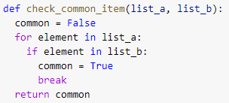

def check_common_item(list_a, list_b):

common = False

for element in list_a:

if element in list_b:

common = True

break

return common

Question 6

